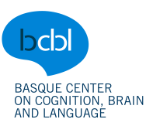 Experiment Request Form (ADULTS)
Please ensure that your request form meets the scientific and ethical guidelines (see GUIDELINES FOR EXPERIMENT REQUESTS document)
REVISED BY:

A) BASIC INFORMATION
EXPERIMENT SHORT NAME (For folder and Participa web) | REPSWITCH
EXPERIMENT EXTENDED NAME | Switching response modalities in picture naming
SUBMITTER | Aikaterini Tsaroucha
OTHER RESEARCHERS INVOLVED | Clara Martin, Svetlana Pinet
DATE OF SUBMISSION
REQUEST TYPE | □ Real experiment  □ Pilot (more than 5 subjects)  □ Normative or survey  □ Follow-up study:  Name of previous study: ______________ Ticket Number: ______________
LOCATION | □ MIRAMON □ KORTA □ MURCIA* □ ONLINE  □ OTHER: _____________ □ MULTIPLE LOCATIONS: ______________  * For this laboratory, it is necessary to fill in the corresponding annex at the end of this document.
TECHNIQUE | □ Behavioral □ Questionnaires/Survey/Normative* (face-to face)  □ Eye-Tracking □ EEG □ ONLINE (Survey/ normative/experiment)  □ MEG □ MRI □ Kinect
SESSIONS | Number of sessions: 1  Duration of sessions:  Session 1: 90’ Session 2: Session 3: Session 4: Session 5: Session 6:  Total duration of experiment: 90’
Rate hourly by experiment (subject pay included)
MR | 500 €
MEG | 500 €
EYE TRACKING / KINECT | 60 €
EEG | 60 €
BEHAVIOURAL CABIN  ONLINE* | 25 €  25 €
Cost to be covered by: | □BCBL  □Other(please specify) ________
No. participants | 48
Session duration & technique | 90minBEH
Total cost | 1200 €

FUNDING: Please, make a breakdown if it is a multiple-day or a multi-technique experiment.
RATE: The rate includes the estimated cost of the session per hour, including the payment to participants + technical and HR costs.
Other costs:
- Travel costs: _____________
- Reward for participants: □ Gift □ Money □ None
*IMPORTANT NOTE FOR ONLINE EXPERIMENTS: if participants are non EU citizens, bank transfer costs may vary. Contact Amets Esnal (a.esnal@bcbl.eu) for further info.

B) EXPERIMENT DESCRIPTION
- Extended description for committees (scientific, ethics, and lab). Give full details of experiment design (aim, hypothesis, script description, methods, data analysis, no word limit). Please explain also why you think this sample size is appropriate (keep in mind there is no single right answer to this question, but try to explain why you believe your sample size is appropriate. If an estimate of the size of an effect is given, specify the unit of measurement too, e.g., Cohen’s d).
Theoretical context:
Research on language production and particularly on the influence of phonology and orthography in L1 language production has indicated an interplay between the oral and written output modalities. Output modality in picture naming refers to naming an object either by uttering the name (speaking) or by writing the name down (handwriting/typing). Evidence supports the activation of both orthographic representations during oral production (Rastle et al., 2011) and phonological representations during written production (Bonin et al., 2001). Furthermore, research on numerical-judgement tasks that tapped on task execution and task inhibition by means of manipulating response modality (oral vs. motor) has indicated that switch costs occurred when switching from one modality to the other (Philipp & Koch, 2005; Philipp & Koch, 2011; Philipp et al., 2013). More specifically, switching between response modalities prompted longer response latencies and higher error rates than in modality repetition (oral, finger, foot). These results suggest that the interplay of output modalities in task switching is seemingly asymmetrical.
Switch cost – being slower when switching from a to b than when repeating
Asymmetrical – you have a bigger cost when switching from a to b than from b to a
The same pattern seems to arise in language switching. Extensive research has focused on the cognitive underpinnings of oral production in the context of bilingualism with the aim of exploring how bilingual and multilingual speakers manage to use one of their languages without (much) interference from the other language(s), also employing the switching paradigm. Research on language switching (Costa & Santesteban, 2004; Filippi et al., 2014; Jevtović et al., 2020) has shown that when asked to name objects switching between their two languages, participants tended to be slower in switching from their second (L2) to their first language (L1) than vice versa. These higher switching costs are explained in terms of inhibition and the asymmetry is interpreted as a result of one language being more dominant than the other (Meuter & Allport, 1999; Macizo et al., 2012).
Returning to language production and modality switching, the literature suggests that phonology is more dominant than orthography in terms of the activation of representations during language production (Luria, 1970; Scinto, 1986; Miceli et al., 1997), mainly because our ability to speak in our dominant language chronologically precedes our ability to write and thus, orthographic representations necessarily build on phonological ones. In other words, it is suggested that the interplay between oral and written output modalities should be asymmetrical. This claim we will attempt to unpack in a response-modality switching experiment in which picture naming will be conducted by switching between written and spoken responses. We will also test modality switch in terms of typing and speaking instead of handwriting and speaking (Wong & Maurer, 2021), taking into consideration the fact that typing is pervasive in replacing handwriting as the preferred way of written communication (Pinet et al., 2016; Pinet et al., 2022). – analogy with lang switching falls short – Is there a switch cost? Is it asymmetrical? Introduce the RQ(s)
Objective:
We are interested in the interplay and dynamics of the activation of orthographic and phonological representations in language production. More specifically, we will examine whether orthographic and phonological representations are constantly co-activated during word production and whether this co-activation is (a)symmetrical/ symmetrical or not in native speakers of Spanish. To that aim, we will ask participants to switch between response modalities, namely speaking and typing, in a picture naming task.

Main hypotheses:
1. Response latencies for typing are expected to be longer than for speaking. (probably not included)
2. Response latencies are also expected to be overall quicker between repeat trials than between switch trials irrespective of modality (typing, speaking).
3. Durations are expected to be shorter in repeat trials (same modality: type-type / speak-speak) in which the same item will be named. In filler trials where participants should name different items but within the same modality, durations should not be much longer than in repeat trials. Durations in switch trials (same item, different modality) should be the longest. This pattern is expected to be the same both for typing and for speaking durations. (last one – more explanatory – not so strong, perhaps not now here).
4. If phonology is strongly co-activated when typing, larger switch costs to typing than to speaking (for the same item) are expected. If orthography is also strongly co-activated when speaking, we do not expect larger switch costs to speaking than those to typing (Figure 1).
4.1. If both phonology and orthography are equally strongly co-activated while typing and speaking, respectively, the switching costs should be equal but very small in the two processes (Figure 2).
4.2. If phonology is weakly co-activated in typing and orthography is weakly co-activated in speaking, the costs in these two processes should be equal and the switch costs that will occur very big (Figure 3).
Note on images: The width of the arrows indicates weak or strong co-activation of representations (thin arrow: weak co-activation – thick arrow: strong co-activation). The red boxes indicate the difference in RT/SOT between switch and repeat trials. The symbol in the middle indicates the difference of switch costs in switching from speaking to typing (above) and in switching from typing to speaking (below).

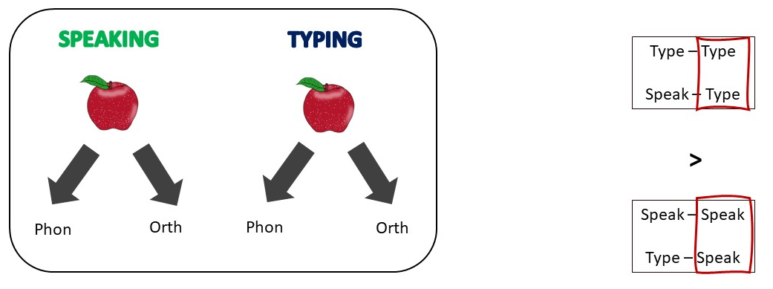
Image 1. Strong co-activation of phonology in typing and of orthography in speaking lead to larger switch costs in switching from speaking to typing.

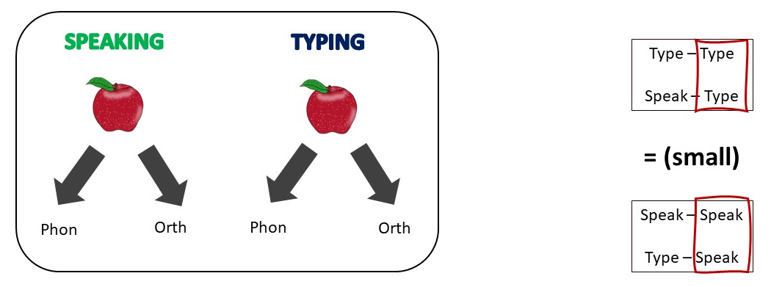
Image 2. Equally strong co-activation of phonology in typing and of orthography in speaking results in equally small switch costs when switching either from speaking to typing or vice versa.

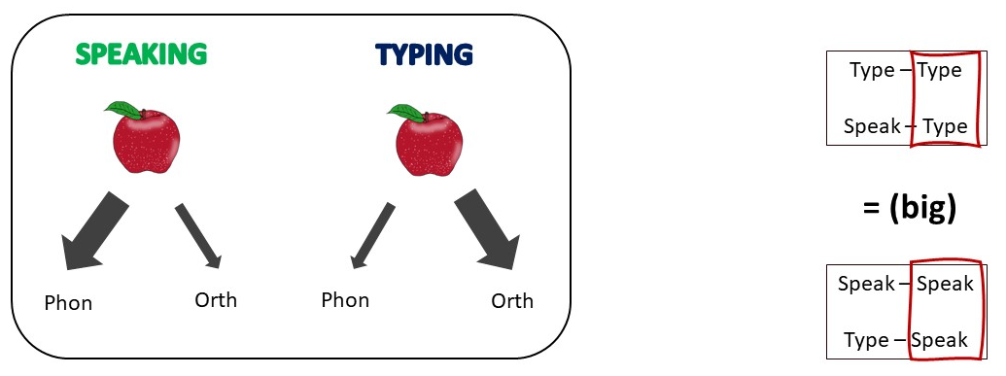
Image 3. Equally weak co-activation of phonology in typing and of orthography in speaking leads to equally big switch costs when switching either from speaking to typing or vice versa.
Participants:
Forty-eight native speakers of Spanish will be recruited. We will attempt to keep knowledge of further languages, such as Basque and English, at a low level. The number of participants is based on existing literature on task/modality and language switching (Philipp & Koch, 2011; Schaeffner et al., 2017; Frances et al., 2021; Wong & Maurer, 2021).

Stimuli:
N di- and trisyllabic Spanish nouns and single and disyllabic English nouns will be employed. The stimuli are matched in terms of grapheme and phoneme length, number of syllables, and logarithmic frequency. Inverse phonological and orthographic similarity are also controlled for with stimuli between languages having low to medium phonological and orthographic similarity to avoid cognate effects in language production. The respective images are controlled for imageability, visual complexity, and name agreement measures. . -- make sure there is no feedback or feedforward inconsistency in the Spanish stimuli

Design:
The picture naming task will involve response modality switch, whereby the participants’ task will be asked to attend to the colour cue in each trial and accordingly name a picture either by typing or by speaking. Typing and speaking trials will either follow one another or interchange, so that participants will see repeat trials (two typing/speaking trials) or switch trials (one trial per response modality). There will also be filler trials (same modality but different items) to ensure that participants do not predict the order of modality switch and/or item appearance. Modality sequence (repeat vs. switch) and response modality (typing vs. speaking) will be within-subjects independent variables. Reaction times (typing), speech onset time (SOT, speaking), accuracy in percentage, and durations (both for typing and for speaking) will be the dependent variables.

Procedure:
The experiment consists of one session and will begin with a familiarisation phase. In the familiarisation phase, participants will be presented with a randomised sequence of the target pictures and they will be asked to name each object. Feedback will be provided when a different word than the one expected is used. A second naming session will be performed to ensure that each participant has named each object as expected. A picture naming task constitutes the main experimental task. The participants will be asked to either type or utter the name of the object presented on the screen. They will view a set of pictures with different colour backgrounds and they will be informed that colour A required this word to be typed, while colour B requires for this word to be uttered. Colour-modality associations will be counter-balanced between participants. Participants will be trained on the color-modality association before starting the main experimental trials. The task will consist of one block with a break every X trials (this will depend on how many trials we will end up with).
Output measures: SOT for speaking, onset latencies in RT for typing, accuracy, durations (for both speaking and typing)
Stats: which comparison? What will I use to show me the switch cost?
Relevance:
The present study will enhance knowledge regarding the interaction of spoken and written output modalities in language production, by informing further on the interplay between phonological and orthographic representations and their activation during speaking and writing. The pragmatic implications of this research cannot also be overlooked since typing and speaking are both basic parts of everyday life and by extension of communication. It is thus important to gain more insight in the dynamics of our two widely employed ways of communicating.
REFERENCES:
Bonin, P., Peereman, R., & Fayol, M. (2001). Do Phonological Codes Constrain the Selection of Orthographic Codes in Written Picture Naming? Journal of Memory and Language, 45(4), 688-720.
Costa, A., & Santesteban, M. (2004). Lexical access in bilingual speech production: Evidence from language switching in highly proficient bilinguals and L2 learners. Journal of memory and Language, 50(4), 491-511.
Filippi, R., Karaminis, T., & Thomas, M. S. (2014). Language switching in bilingual production: Empirical data and computational modelling. Bilingualism: Language and Cognition, 17(2), 294-315.
Frances, C., Navarra-Barindelli, E., & Martin, C. D. (2021). Inhibitory and facilitatory effects of phonological and orthographic similarity on L2 word recognition across modalities in bilinguals. Scientific reports, 11(1), 12812.
Jevtović, M., Duñabeitia, J. A., & de Bruin, A. (2020). How do bilinguals switch between languages in different interactional contexts? A comparison between voluntary and mandatory language switching. Bilingualism: Language and Cognition, 23(2), 401-413.
Luria, A. R. (1970). Traumatic aphasia: Its syndromes, psychology and treatment (No. 5). Walter de Gruyter.
Macizo, P., Bajo, T., & Paolieri, D. (2012). Language switching and language competition. Second Language Research, 28(2), 131-149.
Meuter, R.F.I. & Allport, A. (1999). Bilingual language-switching in naming: asymmetrical costs of language selection. Journal of Memory and Language, 40, 25-40.
Miceli, G., Benvegnù, B., Capasso, R., & Caramazza, A. (1997). The independence of phonological and orthographic lexical forms: Evidence from aphasia. Cognitive Neuropsychology, 14(1), 35-69.
Philipp, A. M., & Koch, I. (2005). Switching of response modalities. The Quarterly Journal of Experimental Psychology Section A, 58(7), 1325-1338.
Philipp, A. M., & Koch, I. (2011). The role of response modalities in cognitive task representations. Advances in Cognitive Psychology, 7, 31.
Philipp, A. M., Weidner, R., Koch, I., & Fink, G. R. (2013). Differential roles of inferior frontal and inferior parietal cortex in task switching: Evidence from stimulus‐categorization switching and response‐modality switching. Human brain mapping, 34(8), 1910-1920.
Pinet, S., Ziegler, J. C., & Alario, F. X. (2016). Typing is writing: Linguistic properties modulate typing execution. Psychonomic bulletin & review, 23, 1898-1906.
Pinet, S., Zielinski, C., Alario, F., & Longcamp, M. (2022). Typing expertise in a large student population. Cognitive Research: Principles and Implications, 7(1), 1-19.
Rastle, K., Mc Cormick, S.F., Bayliss, L. & Davis, C.J. (2011). Orthography influences the perception and production of speech. J Exp Psychol: Learn Mem Cogn, 37(6), 1588-1594.
Schaeffner, S., Fibla, L., & Philipp, A. M. (2017). Bimodal language switching: New insights from signing and typing. Journal of Memory and Language, 94, 1-14.
Scinto, L. F. (1986). Written language and psychological development. Academic Press, Inc.
Wong, W. L., & Maurer, U. (2021). The effects of input and output modalities on language switching between Chinese and English. Bilingualism: Language and Cognition, 24(4), 719-729.

C) PARTICIPANT’S REQUIREMENTS
Approximate Age range: (if more than one group needed, please select all)
□ Young adults (18-35) □ Special population ______
□ Middle aged (36-60) □ Multi-aged: ____________
□ Seniors (>65) □ Other: ________________ □ Notes/+info: ______________________

Languages:
□ Basque-Spanish balanced bilinguals □ Interpreters ________ (please specify)
□ Basque-Spanish unbalanced bilinguals □ Signers ________ (please specify)
□ Almost Spanish monolinguals* (Miramón, Korta) □ HIKA users
□ Almost Spanish monolinguals* (Murcia) □ Other requirements: ________ (please specify)
□ English native speakers

* Keep in mind that English and Spanish subjects are compulsory at school in Spain, and Basque is present in every school (at different levels depending on the school) in the Basque Country, so there are hardly any Spanish or Basque monolinguals nowadays. If you would like to get more information regarding the linguistic background of the area, please request the lab for help from a linguist RA.

- Please indicate any other relevant information regarding the participant profiles:

D) ETHICS FORM AND PARTICIPANTS RECRUITMENT
PARTICIPANT RECRUITMENT
*If you indicated in Section C that your research requires a special population, please include detailed information about participant recruitment in Section L at the end of this form.

□ BCBL Participa database
□ Arrangement with an association (specify): ______________
□ Your own contacts (specify): ______________
□ Other (specify): ______________
* If you are looking for a special population sample, please contact Oihana Vadillo (o.vadillo@bcbl.eu) to proceed with a special recruitment campaign.
ETHICS
- Has the research study been submitted for ethics review elsewhere?
    - □ Yes □ No
    - If so, indicate where and what the outcome was________________________
- If the participants will be recruited through your own contacts/collaborators, specify whether the participants will be tested at BCBL laboratories or elsewhere. □BCBL □ Elsewhere
    - If you selected ‘Elsewhere’, specify the location:_______________________

- If you will receive support from an external organisation for testing your participants, provide full contact details for the organisation and specify whether an agreement has been signed or is in process:________________________________________________________
- Will the research require recruitment advertising? □Yes □ No
- Length of experimental session (as reported in section A):
□ 30 min. or less □30-60 min. □ 60-90 min. □ 90-120 min. □ more than 120 min.

- For experimental sessions longer than 30 minutes, will participants have breaks at least once every half an hour? □ Yes □ No
- Will the study require filling any questionnaires other than the standard BCBL ones (i.e., language background on Participa, BEST, etc.)? If so, please specify and attach a copy of each: □ Yes □ No
- Will the research involve the presentation of emotionally laden material?: □ Yes □ No
  - If so, please upload the stimuli specifying the file names ________________________

IMPORTANT REMINDER: All consent forms and documents containing personal information of participants must follow BCBL standards in terms of format and content, as well as comply with data protection law policies.
Standard consent forms are uploaded in the Lab Section in the wiki. Also, all questionnaires must follow the standard questionnaire template (request template). Other forms and templates are also available (e.g., recording consents, etc.). Please contact Ainhoa Eguiguren (a.eguiguren@bcbl.eu) for support with consent forms and templates.

E) INSTRUCTIONS FOR RUNNING THE EXPERIMENT
Regardless of whether you run the experiment yourself or not, full instructions must be provided. Thus, if we need to replicate the study in the future, we will be able to run it under the same conditions. Please, provide comprehensive instructions to run the experiment (Specific instructions for participants should be given in the next section.) Include specifics such as folder path, file encoding, volume levels, distance between participant and screen, room light, language to use with participants, experiment running properties, order, experiment/counterbalance list, name, etc.

F) INFORMATION FOR PARTICIPANTS
For support with translations, contact Ainhoa Eguiguren (a.eguiguren@bcbl.eu)
* ANNOUNCEMENT OF THE EXPERIMENT that will appear on the Participa website. Try to use clear and appealing language (100 words max). For experiments in Miramón and Korta, unless the participant profile is specifically almost monolingual, this text needs to get translated into Spanish/Basque/English for Participa website or advertising purposes.
English version: □ Not required
Spanish version: □ Not required
Basque version: □ Not required
* OBSERVATIONS for Participa website (optional): Include any information that potential participants need to know (e.g. “It´s important that you have no knowledge of sign language to participate in this study”). For experiments in Miramón and Korta, unless the participant profile is specifically almost monolingual, this text needs to get translated into Spanish/Basque/English for Participa website or advertising purposes.
English version: □ Not required

Spanish version: □ Not required

Basque version: □ Not required

* INSTRUCTIONS FOR PARTICIPANTS DURING THE EXPERIMENT:
Instructions do not have to be in the 3 languages, only in the language(s) used to provide instructions to participants. Please indicate whether instructions will appear on-screen or given verbally, and any other specifications to be considered by lab staff (e.g., do not speak to participants or give consents in X language, etc.).
□ appear on-screen LANGUAGE FOR INSTRUCTIONS ON SCREEN:____________________________
□ should be given verbally LANGUAGE FOR VERBAL INSTRUCTIONS:__________________________
English version: □ Not required

Spanish version: □ Not required

Basque version: □ Not required

* DEBRIEFING FOR PARTICIPANTS (250 words max.) Extended information about the experiment that participants receive via email (or hard copy if necessary) after completing the experiment. (For experiments in Miramón and Korta, unless the participant profile is specifically almost monolingual, this text needs to get translated into Spanish/Basque/English for Participa website or to give to participants).
English version: □ Not required

Spanish version: □ Not required

Basque version: □ Not required

G) INFORMATION ABOUT THE TASK
Stimuli Type | □ Visual □ Auditory □ Audiovisual
Response Type | □ Manual □ Verbal □ Other (specify) ___________
Response devices: | □ Touch Pad □ Gamepad □ Response Box  □ Headphone □ Microphone □ Other (specify) High-precision (NAME) keyboard
Program | □ DMDX □ Matlab □ Presentation □ Experiment Builder □Psychopy □ Other _________
* Please, make a breakdown if it is a multiple-day or a multi-technique experiment

H) SETTINGS BY TECHNIQUE

SPECIAL SETTINGS REQUIRED

Please indicate whether the experiment needs of any special settings and detail the equipment and elements that should be obtained for that purpose that have not been mentioned before (devices, software, etc.):

□ None
□ Yes
□ Microphone
□ Headphones
□ Any other specific device: (NAME) high precision keyboard

□ New software request*: __________________

* BCBL policy does not allow us to install software freely. To be able to do so, a request must be made to the Lab Management, then it must be consulted with all researchers and, if approved, installed on all computers used with that specific technique. For example, if it is requested for the ETR, it must be installed in the Miramon/Korta/Vitoria ETR equipment, which could alter the pace of the experiments that are currently being run. Therefore, before installing any new software, it is convenient to consider if scripts may be modified in such a way that nothing needs to be installed.

I) LAB FACILITIES AND HUMAN RESOURCES
Who is going to run your experiment and when?
(Predocs and Master Students should run their own experiments. If they don’t speak Basque or Spanish and it is required for the experiment, please contact the Lab Managers).
€ During the Lab Hours and by the lab staff
€ During the Lab Hours and by the researcher or colleague from group
€ Out of Lab Hours and by the researcher or colleague from group
€ Out of lab hours and by the lab staff (Only for experiments with special population. Contact Manuel Carreiras, Miguel Arocena or Lab Managers)
€ Experiment of a predoc run externally by themselves (please specify______________)
€ Experiment of a predoc run externally by the lab staff (Murcia/Other) (To be discussed with Lab management-predoc group leader. The predoc will need to make up for those hours helping in any other project of their group leader or in the labs.
€ Experiment run out of Miramon, Korta or Murcia labs. Specify location and needed resources (equipment and personnel)____________________________________________________________________
€ Other: ____________________________________________________________________

- Translation support required to give instructions to participants? □ Yes □ No
If so, please give further details (e.g. language and time required, etc.) ________________________
- Will you need lab assistance to preprocess images/audios during the experiment or after it is finished?
□ No
□ Yes (give details, e.g., program, task…):___________________________________________________

FEEDBACK FOR RESEARCH ASSISTANTS AND COORDINATORS (voluntary)
Is there any other information or article related to the experiment that you think that could be interesting for the lab staff?

J) INFORMATION SHEET
NOTE FOR RESEARCHERS: this “Adults Information Sheet” will be given for participants to read prior to the experiment, together with the basic consent form. For support with translations, contact Ainhoa Eguiguren a.eguiguren@bcbl.eu

You may request a copy of this sheet to any of our staff members

ADULTS INFORMATION SHEET

SHORT NAME OF EXPERIMENT

Name of the researcher(s) in charge of the project: Aikaterini Tsaroucha

You have been invited to take part in this research project. Before you decide if you want to participate, it is important that you understand the purpose of this study and what it implies. Please read the following information carefully and do not hesitate to ask us if you need any additional clarification. Thank you very much.

What is our aim with this study?

[DESCRIPTION OF THE PROJECT. Max. 100 words]

What will you have to do?
Nº of SESSIONS AND DURATION:
TOTAL DURATION OF EXPERIMENT:

[BRIEF DESCRIPTION OF EXPERIMENT. Max. 150 words]

Which technique(s) will be used in this project? What do they involve?

BEHAVIORAL TECHNIQUES
Behavioral studies measure classic variables in Psychology, such as response time or right and wrong responses. These measures are very useful since they allow us to study the mechanisms underlying our cognitive capacities. Stimuli can be visual or auditory and the answers may be given either verbally or manually. The tasks may imply visualizing images, reading words and letters, listening to auditory stimuli, etc. Behavioral studies are generally carried out in soundproof-booths fitted out for this purpose, which have a computer to carry out the tasks.
If you have any questions regarding this technique, do not hesitate to consult the researcher.

What are the possible disadvantages or risks of taking part?
This study is totally safe as long as there are no contraindications with the technique. The researcher will detail if there are any contraindications in this study. Please ask any questions when informed of the technique used in this study. In case you do not feel comfortable, the researchers may stop the session at any time. The BCBL has civil liability insurance in place that covers voluntary participation.

What will happen with my data?
All data collected is strictly confidential and you will not be identifiable in any of the reports, theses or publications resulting from this study. The data from this study will be stored securely throughout the study. Since this experiment is not for diagnostic or clinical but research purposes, you will not be provided with information about your individual results. This study will not be used for commercial purposes.
If you decide to withdraw and your data become identifiable to the research team, you may request for your data not be used.
The summary of the hypothesis and the aim of the project will be sent by email (or a hard copy if necessary) once the experiment is finished, in order to avoid conditioning your answers during the tests.

Do I have to take part?
Your participation in the study is completely voluntary. If you decide not to take part, it will have no impact on your professional activity. If you wish to participate, you will receive a consent form for you to sign and you are entitled to request a copy of this information sheet. You are free to withdraw from the study at any time without giving specific reasons.

Who may I contact regarding this study?
For any questions regarding this study, please do not hesitate to send an email to participa@bcbl.eu indicating the name of the project (xxxxxxxxxxx) and the name of the researcher responsible for it (Aikaterini Tsaroucha).

Thank you very much for your interest in our study.
Aikaterini Tsaroucha

Si lo deseas, solicita una copia de esta hoja informativa

HOJA INFORMATIVA ADULTOS

NOMBRE ABREVIADO DEL EXPERIMENTO

Investigador(es) responsable(s) del proyecto: Aikaterini Tsaroucha

Has sido invitado a formar parte de este proyecto de investigación. Antes de decidir si deseas participar, es importante que entiendas el propósito de este estudio y lo que implica. Por favor, lee detenidamente la siguiente información y no dudes en preguntarnos si precisas alguna aclaración adicional. Muchas gracias.

¿Cuál es nuestro objetivo con este estudio?

[DESCRIPCIÓN DEL PROYECTO. Máx. 100 palabras]

¿Qué tendrás que hacer?
Nº SESIONES Y SU DURACIÓN:
DURACIÓN TOTAL EXPERIMENTO:

[BREVE DESCRIPCIÓN DEL EXPERIMENTO. Máx. 150 palabras]

¿En qué consiste(n) la(s) técnica(s) que vamos a emplear?

TÉCNICAS CONDUCTUALES

Los estudios conductuales miden variables clásicas en Psicología, como el tiempo de respuesta o los aciertos y errores al responder. La utilidad de estas medidas reside en que permiten estudiar los mecanismos subyacentes a nuestras capacidades cognitivas. Los estímulos pueden presentarse de manera visual o auditiva y las respuestas se dan de dos formas: manual y verbal. Las tareas consisten, a grandes rasgos, en visualizar imágenes, leer palabras y letras, escuchar estímulos auditivos, etc. Los estudios conductuales se llevan a cabo generalmente en cabinas insonorizadas habilitadas para ello, que disponen de un ordenador para ejecutar las tareas.
Si tienes cualquier pregunta respecto a esta técnica, no dudes en consultar con el investigador.

¿Conlleva este estudio algún tipo de beneficio o riesgo?
Este estudio es totalmente seguro siempre y cuando no haya contraindicaciones con la técnica. El investigador te detallará si hay alguna contraindicación en este estudio. Por favor, pregunta cualquier duda cuando se te informe de la técnica que se usa en este estudio. En caso de que no te sientas cómodo, los investigadores podrán detener la sesión en cualquier momento. El BCBL cuenta con un seguro de responsabilidad civil en vigor que cubre la participación voluntaria.

¿Qué sucederá con mis datos?
Todos los datos recopilados son estrictamente confidenciales y no se te podrá identificar en ninguno de los informes, tesis o publicaciones que resulten de este estudio. Los datos de este estudio se almacenarán de forma segura durante la realización del proyecto. Debido a que este experimento no tiene fines diagnósticos ni clínicos, sino de investigación, no se te podrán proporcionar información sobre tus resultados individuales. Este estudio no se utilizará con fines comerciales.
Si decides abandonar el estudio y tus datos resultan identificables para el equipo de investigación, tienes derecho a solicitar que tus datos no sean utilizados.
El resumen de la hipótesis y el objetivo del proyecto se enviarán por email (o en papel en caso necesario) una vez finalizado el experimento, para así evitar condicionar tus respuestas durante las pruebas.

¿Qué ocurre si no deseo participar?
Tu participación en el estudio es totalmente voluntaria. Si decidieras no tomar parte, no tendría ningún impacto sobre tu actividad profesional. En caso de querer participar, recibirás un consentimiento para firmar y podrás solicitar una copia de esta hoja informativa y eres libre de abandonar el estudio en cualquier momento, sin alegar motivos específicos.

¿Con quién puedo contactar acerca de este estudio?
Para cualquier pregunta referente a este estudio, por favor no dudes en enviar un email a participa@bcbl.eu indicando el nombre del proyecto (xxxxxxxxx) y el nombre del investigador responsable (Aikaterini Tsaroucha).

Muchas gracias por tu interés en nuestro estudio.

Aikaterini Tsaroucha

Behar izanez gero, eskatu orri honen kopia bat

L) ETHICAL COMMITTEE

RESEARCH INVOLVING ATYPICAL PARTICIPANT POPULATIONS

- DESCRIPTION OF PARTICIPANT POPULATION: _______________________________________________
_____________________________________________________________________________________

- RECRUITMENT OF PARTICIPANTS: (describe the recruitment process in detail)
_____________________________________________________________________________________
_____________________________________________________________________________________
Will support from an external organisation be needed?
€ No
€ Yes:
Full contact details: _____________________________________________________
Agreement contract been signed? € Yes € In process € No (please ask Oihana Vadillo [o.vadillo@bcbl.eu) for advice]

- PARTICIPANTS’ PERSONAL DATA MANAGEMENT:
(Provide a detailed description of the information that will be used to identify and contact participants and the measures that will be taken for data protection, including, but not limited to participant identifying information, contact details, medical information, diagnosis, etc.)
_____________________________________________________________________________________
_____________________________________________________________________________________
_____________________________________________________________________________________
_____________________________________________________________________________________

- ETHICAL ASPECTS AND RISKS:

- Does this participant belong to a vulnerable population* (see descriptions below)?
€ No € Yes (specify)____________________
- Will individual participants in this study encounter difficulties to access, read, or understand the full
information provided in the informed consent form? € No € Yes (specify)____________________

IMPORTANT NOTE: if you responded YES to any of the two previous A and B questions, provide detailed information of the measures taken to mitigate such risks: _____________________________________________________________________________________
_____________________________________________________________________________________

* DESCRIPTIONS OF VULNERABLE POPULATIONS: (If in doubt, please discuss your case with the BCBL ethics committee):

Cognitive or Communicative Vulnerability: The category of cognitive or communicative vulnerability broadly encompasses persons who have difficulty comprehending information and making decisions about participation.

Institutional Vulnerability: The category of institutional vulnerability includes persons who are under the formal authority of others who might have different values, goals, and priorities than those of the potential research participant.

Deferential Vulnerability: Like institutional vulnerability, the deferential vulnerability category includes persons who are under the authority of others.

Medical Vulnerability: The medical vulnerability category includes persons who have serious health conditions for which no satisfactory standard treatment options are available.

Economic Vulnerability: The economic vulnerability category includes persons who are disadvantaged in the distribution of social goods and services such as income, housing, or healthcare.

Social Vulnerability: The social vulnerability category includes persons who belong to undervalued social groups.
(Definitions taken from: http://www.ochsnerjournal.org/content/20/1/34#sec-5)

